**Installing Nagios on AWS EC-2 instance:**

**Step-1**. Install pre-requisite software on your EC2 machine prior to Nagios installation like apache, php, gcc compiler, and gd development libraries.

**sudo su**

**yum install httpd php -y**

**yum install gcc glibc glibc-common -y**

**yum install gd gd-devel -y**

**Step-2.** Create the account information you need to set up a Nagios user.

Run the following commands,

**adduser -m nagios**

**passwd nagios**

**>Now it asks to enter a new password. Give “suitable” as the password.**

**groupadd nagioscmd**

**usermod -a -G nagioscmd nagios**

**usermod -a -G nagioscmd apache**

**Step-3:** Download the Nagios core and the plugins, and create a directory for storing the downloaded files.

**mkdir ~/downloads**

**cd ~/downloads**

**>Download the source code tarballs of both Nagios and the Nagios plugins**

**wget**[**http://prdownloads.sourceforge.net/sourceforge/nagios/nagios-4.0.8.tar.gz**](http://prdownloads.sourceforge.net/sourceforge/nagios/nagios-4.0.8.tar.gz)

**wget**[**http://nagios-plugins.org/download/nagios-plugins-2.0.3.tar.gz**](http://nagios-plugins.org/download/nagios-plugins-2.0.3.tar.gz)

**Step-4**. Compile and install the Nagios, extract the Nagios source code tarball.

**tar zxvf nagios-4.0.8.tar.gz**

**cd nagios-4.0.8**

**>Run the configuration script with the name of the group which you have created in the above step**

**./configure — with-command-group=nagioscmd**

**>Compile the Nagios source code**

**make all**

**>Install Binaries, init script, sample config files, and set permissions on the external command directly.**

**make install**

**make install-init**

**make install-config**

**make install-commandmode**

**Note: We can change the mail in Nagios server.**

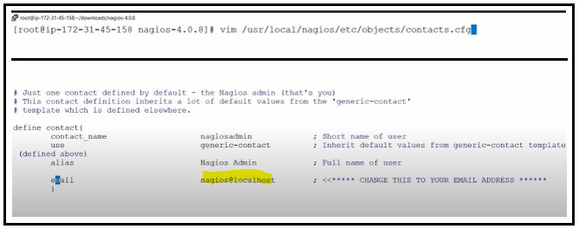

**Step-5.** Configure the web interface.

**make install-webconf**

**Step-6**. Create a ‘nagiosadmin’ account to login into the Nagios web interface

**->set password as well**

**htpasswd -c /usr/local/nagios/etc/htpasswd.users nagiosadmin**

**>asking for password, set a new password**

**>Restart httpd service.**

**service httpd restart**

**Step-7.** Compile and install the Nagios plugins, and extract the Nagios plugins source code tarball.

**cd ~/downloads**

**tar zxvf nagios-plugins-2.0.3.tar.gz**

**cd nagios-plugins-2.0.3**

**>Compile and install the plugins**

**./configure — with-nagios-user=nagios — with-nagios-group=nagios**

**make**

**make install**

**Step-8.** Start Nagios. Add Nagios to the list of system services and have it automatically start when the system boots.

**chkconfig — add nagios**

**chkconfig nagios on**

**>Verify the sample Nagios configuration files**

**/usr/local/nagios/bin/nagios -v /usr/local/nagios/etc/nagios.cfg**

**>If there are no errors, start Nagios**

**service nagios start**

**service httpd restart**

**Step-9.** Copy public_ip of ec2 instances and paste it on google.

**For eg-> 3.80.147.160/nagios/**

Login with username and password.

